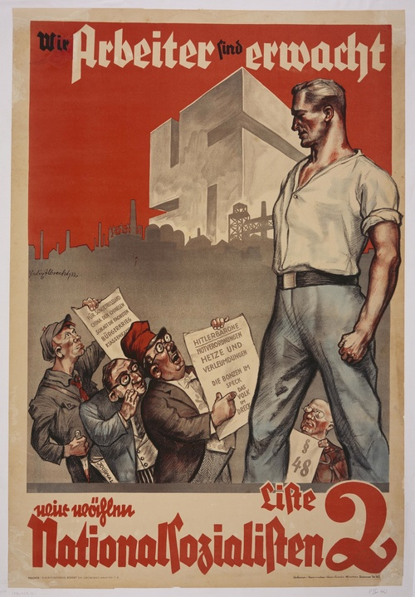
This July 1932 election poster shows the German worker, enlightened through National Socialism, towering over his opponents. It reads "We Workers Have Awakened. We're Voting National Socialist." Credit: U.S. Holocaust Memorial Museum.

Poster: "Against Corruption / Vote for National Socialists / Hitler Movement!"

The Nazi Party denounced the Weimar government for its corrupt use of state power to enrich its leaders while robbing the German people. Nazi propagandists portrayed their party as guardians of the people, represented here by an industrial and an agricultural worker. Hanpert, artist; undated

http://www.ushmm.org/propaganda/exhibit.html#/records/data/records/poster-vote-nazi.xml
