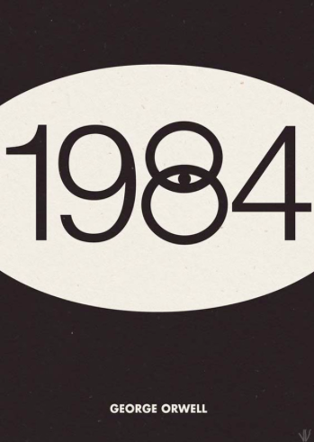
Propaganda and 1984 – Visual Project

Part of the focus for our unit on George Orwell’s 1984 has been on defining, identifying, and analyzing rhetoric and the strategies and techniques that are used to persuade an audience to think or act in a particular way. Thus far, we have examined the art of persuasion in both speeches and in writing. As we have seen in class, visuals, too, can serve as a means of persuasion.

The Party knows all too well the profound impact of carefully constructed rhetoric and propaganda and their impact on the citizens of Oceania. For this task, I want you to imagine you are a party member employed in the Ministry of Truth. Your task for this project will be to create propaganda for the Party to disseminate to the lower party members.

PART I:
Your job will be to select one of the ways the party passes its ideology down to the citizens of Oceania and create an effectively persuasive visual representation for it. For example, you may create propaganda that encourages participation in the Junior Spies, warns people of the dangers of thought crime, or encourages attendance to the public executions. The idea is that you choose a topic that promotes compliance with any of the institutions of The Party. As you construct your poster, think carefully about the aim/intention for the propaganda as well as your target audience. What can you do with your poster to reach or meet that aim? How can you most effectively appeal to the target audience?

PART II:
Complete the Five Cs Observation Protocol for your propaganda poster. Please be specific and use concrete details as you complete the protocol observation sheet.

PART III:
Conduct a close and careful rhetorical analysis of your visual. Using the procedure and specifications discussed in class, you will compose an introduction paragraph and one analytical paragraph focusing on the way specific elements in your poster that work to persuade the target audience into thinking or acting in a specific way.

DUE: ___________________________________________

