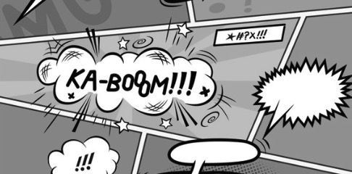
Diction in Frankenstein – Comic Strip Project
PG. ______

Background:

At this point, we have developed a working understanding of diction, or an author’s word choice. We have carefully and closely examined diction in the opening pages of Chapter 5. In analyzing the specific words Shelley uses, we have developed a greater understanding of setting, character, and character responses.

Diction has helped us to create an image of the setting, characters, and emotion of the opening pages of Chapter 5. For this project, we are going to take what we have learned about diction and turn it into a comic strip that conveys both the images and emotion that Shelley’s word choice has created.

Assignment:

You will use your reading tracker, annotations, and understanding of the author’s diction to help you develop a comic strip that conveys the events, images, and emotion of the scene where Victor Frankenstein finally brings his creature to life. See below for the requirements:

- Your comic strip must contain at least six complete frames illustrating important aspects from the opening pages.
- The images you create MUST be relevant and connected to the examples of diction that we focused on in class. You cannot draw unicorns and rainbows.
- You must incorporate color.
- You should incorporate some text in each frame. Whether it is a quote or the specific words that you’re focusing on for that particular scene.

How will I be graded?

The comic strip project will be worth 50 points. The point breakdown is as follows:

15 Points: Understanding of the novel and the characters
Does your comic strip clearly indicate that you understand the story and the character your are supporting? Is the information presented in your comic factually correct and/or could be reasonably assumed?

15 Points: Effectiveness
Does your comic convey an understanding of the impact of an author’s word choice on meaning? Do you use both images and text to convey important information about setting, plot, and character/character motivation?

10 Points: Design and neatness
Is your poster designed thoughtfully and is it executed neatly? Did you use care and take time in creating your poster? Is it colorful and interesting to look at?

10 Points: Use of class time
When given time in class, did you use your time effectively? Did you use the time to look up words, create a draft, and carefully execute the completion of your project?
What if I’m not so great at drawing?

Play to your strengths. If you can’t draw people very well, don’t design a poster that has people in it. If you’re good at bubble letter, go for it! If you can’t draw but you have access to graphic design software, please feel free to create a digital poster. Remember, there is a difference between being bad at drawing and not caring; if you submit a poster that was clearly just sketched in pencil a few minutes before the deadline, you will NOT receive credit.

When is this assignment due?

You will be given some class time to work on your projects. Anything that you do not finish in the time allotted will be homework.

Completed projects need to be submitted at the beginning of class on ______________________________________

